Cyclists demand access to rural footpaths
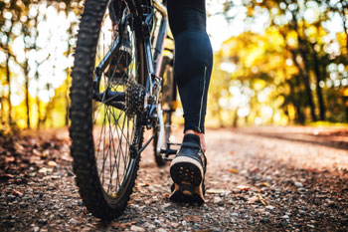

British cyclists are calling for a reform of England’s rights of way legislation to allow bikes onto country footpaths - a call resisted by walkers.
The group British Cycling argues that countryside paths should be opened up to everyone – cyclists and ramblers alike – so that everyone can enjoy them.
‘We need to open up our countryside paths to be enjoyed responsibly by everyone, in a healthy, non-polluting way. That’s what I want for my kids and family,’ British Cycling’s policy advisor, Chris Boardman, said.
He argues that it works in Scotland where there is open access to all: ‘There is no reason to presume it would be different in England.’
Responding to concerns about the risks of allowing inconsiderate cyclists onto footpaths, Mr Boardman pointed out that this was no reason to ban all cyclists.
‘Of course, some people can be inconsiderate to others and we agree that there should be a code of conduct where walkers should take precedent,’ he said.
‘However, we shouldn’t ban everyone for the poor behaviour of a few – that would be like banning walkers because some people litter or let their dogs foul.’
Gemma Cantelo, head of policy and advocacy with The Ramblers, disagrees with the proposal to open up rural footpaths to everyone.
‘Some footpaths aren’t suitable for shared use because of their physical characteristics, e.g. blind bends, unsuitable surfaces,’ she said
However, she added that in certain circumstances it would make sense to upgrade rural footpaths for cycling because this would improve the path for walkers.
‘That’s why we think upgrading footpaths to multi-use should be decided on a case-by-case basis, taking account of local circumstances, keeping the safety of all users paramount,’ she said.
‘We are keen to work with cyclists, horse riders and other users to shape joint approaches to this issue and help to introduce a clear code of responsible behaviour and associated behaviour change campaign.’

