The Future of New Forest Association of Local Councils
Members
You will no doubt recall that during 2010 under the initiative of Ringwood and Hythe councils NFALC was reorganised and re-launched in its present form, primarily to give the 37 New Forest town and parish councils a conduit to NFDC, the NFNPA and County.
Noting that on average only a third of local councils attend NFALC meetings, with a third never attending, I had for some considerable time harboured concerns about larger councils’ lack of support and these thoughts were shared by our Co-ordinator. To this end, on 20 June 2018 we met with Bob Jackson CEO of NFDC, Steve Avery Director of NFNPA and Rosemary Rutins from NFDC Democratic Services to discuss the future of NFALC.
The long and short of the meeting was that NFDC suggested NFALC be split next year after local elections into three or four areas like the NFNPA, each having their own meetings to ensure that agendas deal with local issues. The areas would “come together” at the NFALC AGM. My main concern was how these revised arrangements would fit in with HALC and the position of NFALC Chairman as a director of HALC.
As you are aware, the New Forest National Park Authority (NFNPA) has to comply with government legislation regarding the four quadrants, which effectively means the New Forest District is already divided into four areas. I have attended Quadrant meetings and whilst the content of meetings may be interesting and contain presentations there are no minutes taken so the meetings could be described as “talking shops”?
Bob Jackson previously suggested that the District Association representing 37 local towns and parishes give some thought as to how they might see NFALC’s future, noting NFDC is wishing to engage more with local councils, and already has a Waterside forum. That is something for members to consider prior to the NFALC AGM scheduled for 18 July 2019. Please remember, this Association exists for the benefit of its members.
The purposes of the Association are:
i) To take all action necessary to represent, protect and promote the interests of all local Councils in the New Forest District, and
ii) For those Councils in the New Forest National Park, but outside the New Forest District, to represent their views to the New Forest National Park Authority.
Cllr Goff Beck
Chairman of NFALC
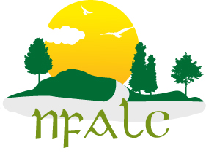

nfalc.org.uk/ 12 April 2019

