The Future of New Forest Association of Local Councils
Members
You will no doubt recall that during 2010 under the initiative of Ringwood and Hythe councils NFALC was reorganised and re-launched in its present form, primarily to give the 37 New Forest town and parish councils a conduit to NFDC, the NFNPA and County.
I have for some considerable time harboured concerns about larger councils’ lack of support and these thoughts are shared by our Co-ordinator. To this end, I recently arranged a meeting with the CEO of NFDC, deputy CEO of the NFNPA, NFALC Co-ordinator and Rosemary Rutins from NFDC Democratic Services who was also in attendance.
The long and short of the meeting is that NFDC are suggesting NFALC be split next year after local elections into three or four areas like the NFNPA, each having their own meetings to ensure that agendas deal with local issues. The areas would “come together” at the NFALC AGM. My main concern is how these revised arrangements would fit in with HALC - and my position as a director of HALC, being Chairman of NFALC?
As you are aware, the New Forest National Park Authority (NFNPA) has to comply with government legislation regarding the four quadrants which effectively means the New Forest District is already divided into four areas. I have attended Quadrant meetings and whilst the content of meetings may be interesting and contain presentations there are no minutes taken so the meetings could be described as “talking shops”?
Bob Jackson has suggested that as the District Association representing 37 local towns and parishes we give some thought as to how we might see NFALC’s future and include this on our October agenda for further discussion and consideration.
I am to understand that at the last District Conservative Group “political” meeting, the future of NFALC was mentioned – sadly, neither myself as Chairman of NFALC, nor the Vice Chairman or Co-ordinator for that matter were invited to give their views.
Please bear in mind the Association exists for the benefit of its members, remembering…
The purposes of the Association are:-
i) To take all action necessary to represent, protect and promote the interests of all local Councils in the New Forest District, and
ii) For those Councils in the New Forest National Park, but outside the New Forest District, to represent their views to the New Forest National Park Authority.
Cllr Goff Beck
Chairman of NFALC
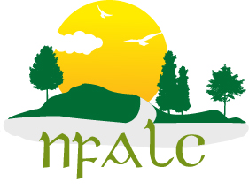
nfalc.org.uk/

