

**Parishes Autumn Briefing**

**13th December 2017** *(map attached)*

**6.30pm – 8.30pm**

Ashburton Hall, ground floor, Hampshire County Council, Elizabeth II Court, The Castle, Winchester, SO23 8UD

**Agenda**

|  |  |
| --- | --- |
| **6pm** | **Arrival, Registration and Refreshments \*** |
| **6.30pm** | **Welcome**  *Parishes will be welcomed to the Autumn Briefing before Cllr Rob Humby, Executive Member for Environment and Transport (HCC) takes the floor.* |
| **6.35pm** | **Introduction**  *Presentation by Cllr Rob Humby, Executive Member for Environment & Transport (HCC) - who will give an introduction to the services delivered by ETE, before introducing the two main topics of the evening.* |
| **6.50pm** | **Hampshire’s Future Transport Network - Links with the Wider SE Network**  *Presentation by Keith Willcox, Assistant Director, Transport (HCC) – who will provide a briefing on plans to develop a robust, forward thinking Transport Strategy, encapsulating some of the most critical issues for Hampshire’s own transport network. TfSE is set to become the key mechanism for the South East to secure national investment in its transport systems which is critical if the region is to meet current growth pressures and to ensure its economy remains the UK’s primary economic powerhouse outside of London.* |
| **7.20pm** | **Break \*** |
| **7.40pm** | **The New Hampshire Highways Service Contract**  *Presentation by Colin Taylor, Deputy Director - Highways, Traffic and Transport (HCC) and Simon White, Operations Director (Skanska), who will provide a presentation on the new Hampshire Highways Service Contract. The contract heralds a significant change in the way we will deliver highway maintenance across Hampshire for the next seven to twelve years. We’d like to invite you to find out more about how this contract was developed to fit the new highways operating model, how it will work, what’s in scope and what we are setting out to achieve as we embark on this innovative new way of working.* |
| **8.15pm** | **Q&A’s**  *An opportunity for Parishes and Councils to ask the presenters and Stuart Jarvis, Director of Economy, Transport and Environment (HCC), questions on the evenings presentations – Chaired by* *Cllr Rob Humby, Executive Member for Environment and Transport.* |
| **8.30pm** | **Closing Remarks**  *Provided by Cllr Rob Humby, Executive Member for Environment & Transport.* |
|  | **Close \*** |

*\* Participants will have the opportunity to look at our interactive displays including How to Report Highway Issues, How to View Live Information on the Highway, and Advances in Digital Innovation (Skanska).* *In addition, we hope to be able to offer Parishes an exciting opportunity to view the new innovative road repair equipment (Dragon Patcher) and Winter Maintenance Vehicle/s, incorporating our state of the art digital technology however this is subject to availability.*

**Map of Winchester**

**Hampshire County Council, Elizabeth II Court, The Castle, Winchester, SO23 8UD**

(please note it is free to park in the Tower Street Car Park after 6pm)

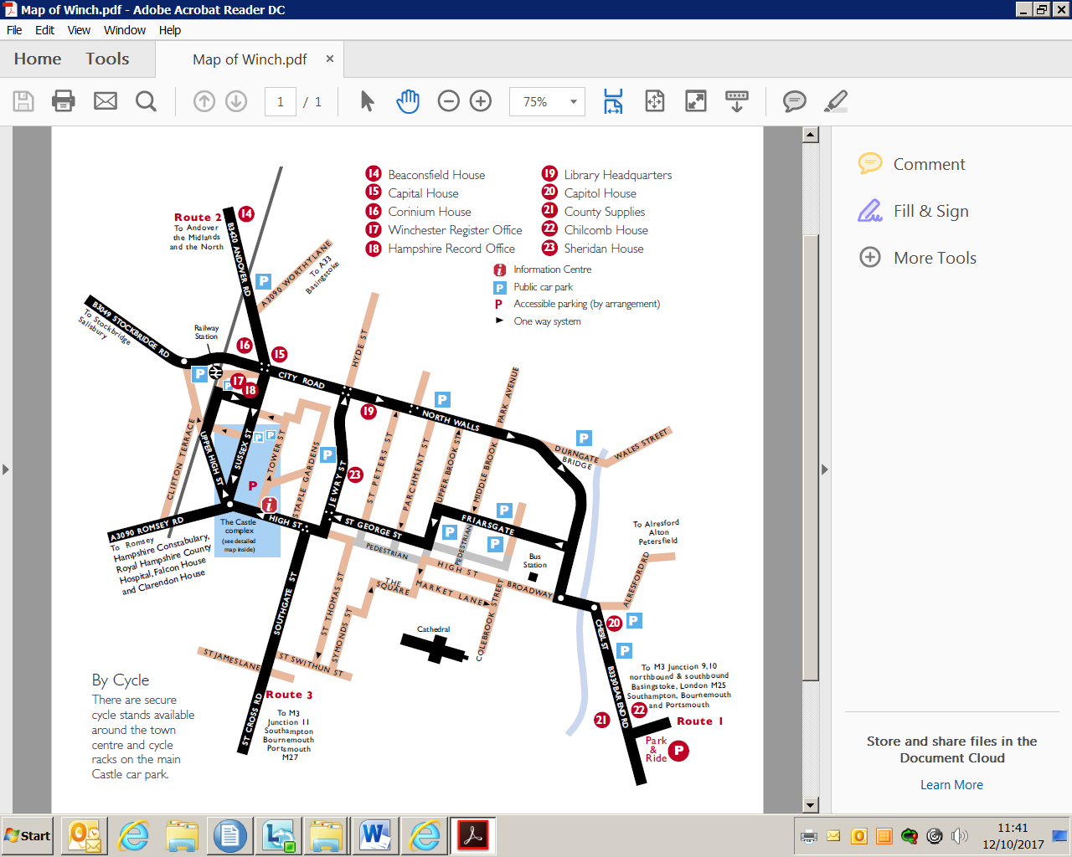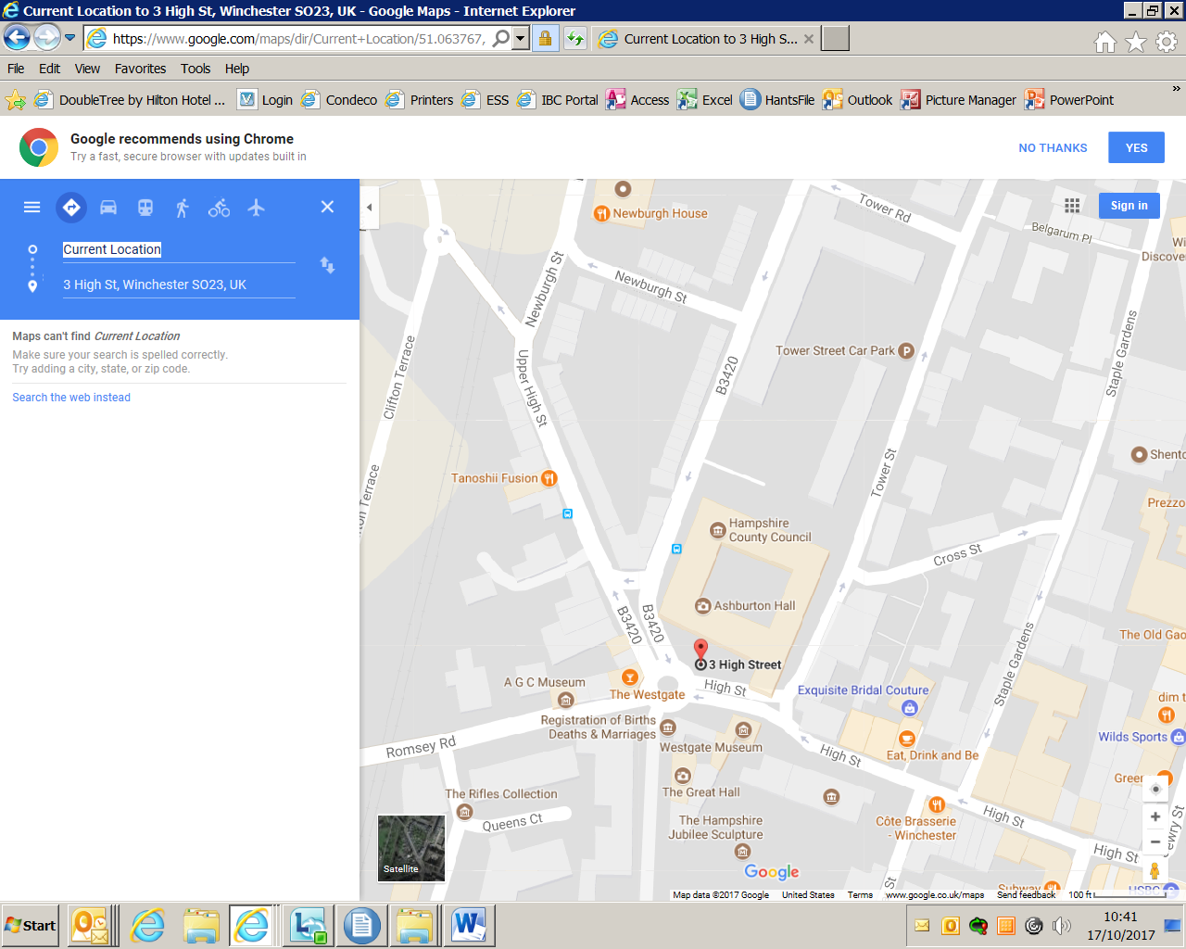

Alternatively you can get directions by clicking on <https://www.google.com/maps/dir/50.967182,-1.374688/51.063767,-1.319357/@51.0158295,-1.4046738,12z/data=!3m1!4b1!4m4!4m3!1m1!4e1!1m0>