21 July, 2017

Still no decision on council merger plans

PARLIAMENT has broken up for the summer holidays leaving the Future Dorset plans up in the air.
Councils have been awaiting the Government's response to the proposal since it was submitted in March however, what with a snap General Election and the start of Brexit negotiations, no response has been forthcoming.
In the meantime, those councils which back the supposedly cost-saving plan have been taking steps to prepare themselves for the response. Parliament is not due to sit again until September 5.
At a cabinet meeting on Wednesday, Bournemouth councillors agreed to establish a 'joint officer structure' with Poole, sharing staff for all services between the boroughs and their combined 340,000 residents.
The move, already agreed by Borough of Poole's cabinet, now needs approval from both full councils. Bournemouth council leader John Beesley said the move would help the authority prepare for Future Dorset, should it be approved.
"Creating a single staffing structure serving both councils would help us achieve the savings we must make and would also lay the foundations for a new unitary council for the conurbation should the Government approve our Future Dorset proposal," he said.
"The two councils have a strong track record of working together to deliver services. Through an extended period of budget constraints, Bournemouth and Poole must save a further £27.8 million between 2018 and 2021. Staying as we are is not an option. Work is already underway to create joint services for libraries, tourism and seafront operations. A single corporate services team providing important back-office functions, including finance, HR, IT, legal and other support teams, for both councils will also be created by April 2018."
The council says combining staff will leave both authorities with their "sovereignty, identity and democratic processes", as well as their own budgets. A voluntary redundancy scheme is under way at both Bournemouth and Poole.

The Future Dorset, or local government restructuring (LGR) plan, would see Dorset's nine councils reformed into two new unitary authorities. Six councils are backing it and three are opposed.
Last month a spokesman for the six called upon the Secretary of State for Local Government Sajid Javid to announce his decision "at the earliest possible opportunity".
The six have also been considering setting up 'joint committees' to pave the way for the joint implementation committees which will plan the formation of the new councils if the plan is approved.
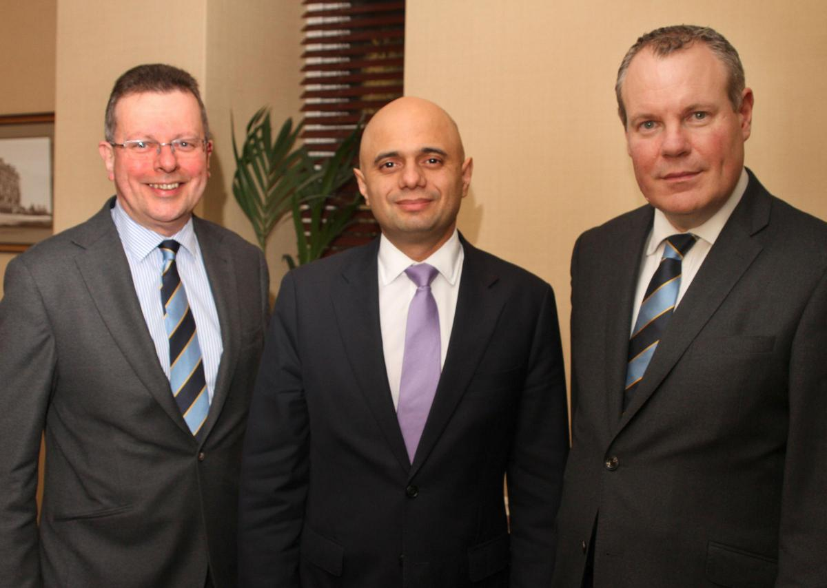
Bournemouth Council Leader Cllr John Beesley (left) with Local Government Secretary Sajid Javid (centre) and Bournemouth West MP Conor Burns (right) earlier this year before General Election.

