Will Solent City be the death of Hampshire?
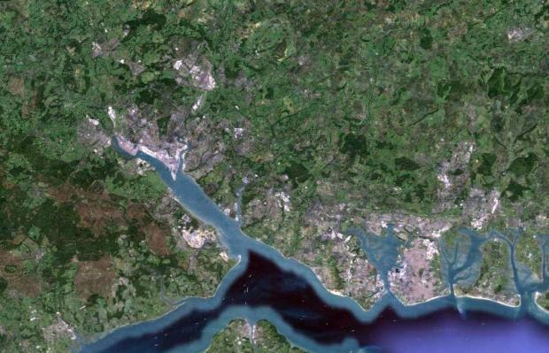
09.03.16
Ian Murray, Editor-in-chief editorianmurray

IMAGINE if you will that it is a few years from hence and we are all living, working and playing in a new entity: Solent City.
This new metropolis, comprising of some 750,000 souls, covers an area stretching from the Waterside and Totton to Havant or perhaps Waterlooville in the east of the county.
Encompassed within this relatively new municipal authority are the cities of Southampton and Portsmouth and the large prosperous towns of Eastleigh, Romsey, Fareham and Gosport as well as the villages and hamlets between.
Welcome then to the Southern Powerhouse.
And to the north, cut off from this vibrant, energetic, forward-thrusting entity? The remnants of the old Hampshire County Council, still centred on Winchester, although with its base so far in the south of this now truncated body, battling to prevent bright, surging Basingstoke from stealing the title of capital of Upper Hampshire.
Gone then are the current scattering of borough and district councils – Eastleigh, Test Valley, Meon Valley, Fareham, Gosport, Havant and Waterlooville – although town councils now enable the links with local populations to remain, of a fashion.
Fantasy? Not according to the leader of Hampshire County Council (HCC) Roy Perry who this week reacted with horror at news that a number of local authorities in the south of the county were in negotiation with the government to create a breakaway region that will cut The Castle – as the HCC authority buildings in Winchester are known – out of the picture.
Those who live comfortably under the benign rule of their local authorities in the south had better beware, he warned, soon they would not exist. And that would mean, he inferred, local communities would lose their identities as they were swallowed whole – or in the case perhaps of the Waterside adjacent to the New Forest, partially – by a new faceless Solent City.
Was he scaremongering? Undoubtedly. Was he right? No. And then again, perhaps. Or, putting it this way: only if we are lucky.
For what is on the cards and what is being negotiated by those who currently run the, let’s call them ‘coastal authorities’ of Hampshire, is not the removal of the existing local authority structure.
Those who have been urging the government this week to recognise the region as ripe for a new tier of local government have no intention of giving up their power bases nor the removal of the existing unitary (Southampton and Portsmouth) and borough (everyone else) bodies. But they do want to break free from the dominance of the County Council itself.
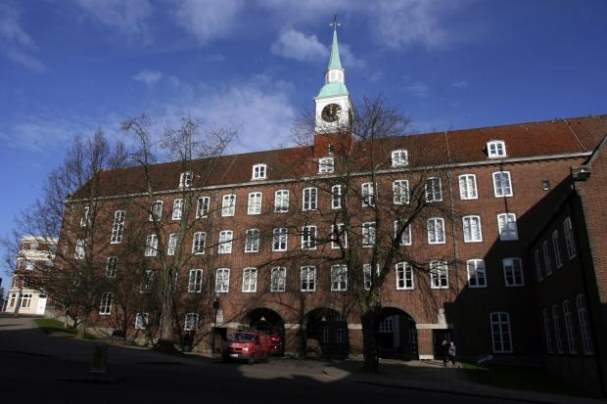The Castle in Winchester
Confused? Of course you are. But then again the structure of the English local government system has never been straightforward and is fraught with archaic historical boundaries, vested interests, political in-fighting and good old fashioned apathy from the voting public who stay away in their droves from local elections.
So what is going on and how did we end up here?
First a little history. The cities of Southampton and Portsmouth were until 1997 part of the administrative authority of Hampshire and as such bowed to The Castle for matters such as transport, planning and education (in fact, until 1959 the county was known as the County of Southampton or even Southamptonshire, although the term Hampshire was widely used).
In 1997 the two cities became unitary authorities responsible for all within their boundaries. Towns outside of these two cities still look to Winchester and HCC for education, social welfare and highways but a number of smaller borough and district councils (Eastleigh Borough and New Forest District for instance) look after planning, rubbish collection and a range of other services.
This state of affairs has bumped along uneasily for two decades, but in recent years there has been growing tension between the larger unitary authorities and the County with its borough and district offspring as the cities push against their boundaries. In Southampton where the M27 creates almost a northern border, Eastleigh and Test valley councils have consistently thwarted plans – or attempted to – for development on their southern borders. To the west and across Southampton water, the New Forest District Council has acted to protect its flanks against incursions.
As both cities have grown they have strained at the leash created by the current local government structure and looked for ways to expand outside of their boundaries. Knock backs for Southampton have included the opposition from New Forest District Council to plans to expand Southampton docks at Dibden Bay, the proposals to build a new stadium for Southampton FC at Stoneham at the junctions of the M3 and M27, and constant battles along the M271 and M27 corridor with test valley Borough Council over plans for homes, offices and industrial units. And behind all of these smaller councils has sat HCC in support.
Has this been a concerted bid to restrain the growth of the two cities and curtail their power? Some think so, but most likely the actions have been in defence of the status quo, and it is that status quo that is now threatened.
The scene then has been set for some time for the boundaries of the city authorities to be either moved outward or to flex enough to allow the authorities to breathe. All political parties recognise this is a national challenge. This is why Labour in the run up to the last election mooted the idea of forcing smaller councils to accept planning applications for homes on land adjoining larger authorities who are bulging at the seams.
The Tories, who on the whole would like to protect the ‘Shire Counties’ which they traditionally control, also appear to have come to the conclusion that the status quo is not working. But no government wishes to make wholesale changes to the structure of local government in England and Wales.
That way they know is madness, swallowing up countless years of debate, argument and hostility. Far better to try and work with the existing authorities to facilitate change.
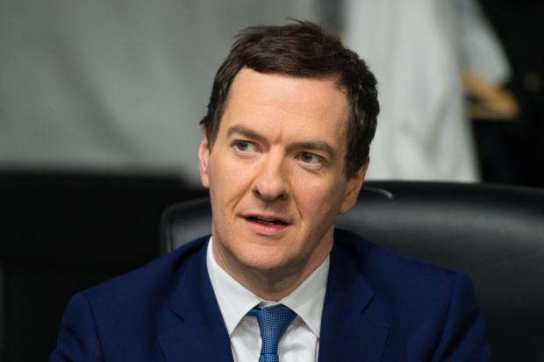George Osborne
And it has been chancellor George Osborne’s plans for so-called Northern Powerhouses bringing together the industrial cities of the Midlands and the North of England into partnerships that has become the catalyst for change. No existing authorities are expected to give up powers – yet – but they have been seduced with the offer of control over billions of pounds of government funding to consider change.
New over-arching tiers of government will be created into which the existing councils will work to carve out the best use of the new funding for infrastructure, transport and other big scale projects in their regions.
And what is good for the North and the Midlands, is good also for the South Coast, which is why politicians here were quick off the mark to raise a flag that we too would like to have control over those billions of pounds of funding.
What’s more, there already exists a body on which just such a Southern Powerhouse could be based. It’s known as PUSH – the Partnership for Southern Hampshire and includes the unitary authorities of Portsmouth, Southampton and the Isle of Wight, and the district authorities of Eastleigh, East Hampshire, Fareham, Gosport, Havant, New Forest, Test Valley and Winchester.
Although officially a ‘Partnership of Hampshire County Council,’ that, some might say, is just a way of keeping the authority happy. For PUSH is very much a gathering of the like-minded – with perhaps the addition of a few who may be not so much on board for a journey into a bold new future (Test Valley, Winchester?).
However, when it became obvious that the members of PUSH were likely to at least explore the chancellor’s offer, the county council came on board. From the start, its leader Councillor Perry made plain his dislike of Mr Osborne’s insistence that any new body must have an elected mayor. This was strange for a Tory leader to argue against one of the main policies of a Tory central government, but not unusual if seen in the light of an authority which considers itself under threat.
And the HCC has form here. The previous leader, Cllr Ken Thornber, mindful of growing pressure on local authorities to merge more services and functions, and a possible threat to the existence of Shire Counties themselves attempted to create his own Hampshire-wide authority to steal the initiative.
The Hampshire Senate, as he named it and then placed himself at its head, was made up of leaders of all local authorities in the county, including Portsmouth and Southampton, and its function was to seek out efficiencies and enact them. Some might say that its function was also to protect the role of the HCC and hegemony over its district councils and maintain the current lock on Southampton and Portsmouth.
Certainly it appeared that while HCC were engaged in negotiations with the government over the proposed new Solent-wide authority, it showed little enthusiasm.
And this week’s bombshell announcement that behind the HCC’s back, the leaders of some of the more progressive authorities – including Southampton, Portsmouth, Eastleigh, Fareham, Gosport, Havant, East Hampshire and the Isle of Wight – have been in talks to go it alone without the HCC.
Cue warnings from Cllr Perry that Hampshire is about to be split in two, much-loved local authorities are to be dissolved and a plague of rats will descend on the area (I made the last one up, of course).
That Cllr Perry is rattled was underscored by the fact he quickly announced he would, after all, consider agreeing to an elected mayor if the new authority being created could still include Hampshire County Council.
But it may be too late, at least for HCC to be included. There is a suspicion that The Castle is seen as part of the problem and not the solution to the region’s need for growth and more autonomy. The Southern Powerhouse does not need the support of the more rural areas of the county, is the harsh reality being spoken behind closed doors and at business gatherings.
That politicians such as the leader of Southampton City Council Cllr Simon Letts have assured residents there will be no changes to the current structure of local government in Hampshire under the discussions they are having with Whitehall will no doubt comfort many, but disappoint business leaders.
Business hopes the Southern Powerhouse will be more than just a new tier of government with access to infrastructure funds headed by an elected mayor. Business hopes the change will usher in a new era where boundaries are broken down, protectionism weakened and commerce allowed to breathe. More jobs, more homes, more investment they say. Quietly, many local politicians may agree with them but understand that to say so out loud may spook the horses.
Are we then on the cusp of a new map of local government being drawn for Hampshire? I believe so. But how far the map changes will depend on how brave are our politicians – and how brave are we.

