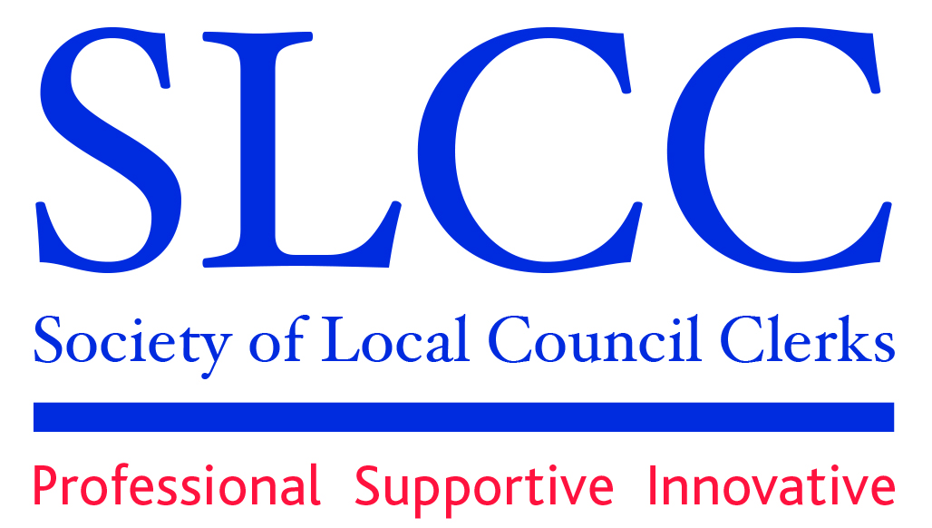

Hampshire Branch Meeting

Thursday 11th February 2016.
Starting at 10.00am with the presentation at 10.30am.
Stanmore Community Centre
Somers Close, Stanmore, Winchester, SO22 4EJ

Devolution update

Presentation by James Strachan
Assistant Director for Devolution (Interim) HCC

- How will the Devolution affect Parish Councils?
- What role can Parish Councils play in the process?
- What has happened so far and what is to come?

This meeting is a must for everyone as the devolution of services in Hampshire will affect us all.

This is a free and open event. Both members and non-members are welcome to attend. If you are not a member come along and see what SLCC can offer.

If you are coming to the meeting why don’t you contact a neighbouring parish, or two, and come together.

M Wathen, Secretary,
12th January 2016.

